Interfacing PHP with MySQL

LAB REPORT # 6



**Spring 2023**

**Data Base Management System Lab**

Submitted by:

Hamid Rehman

Registration No.:

20PWCSE1969

Class Section:

**C**

“On my honor, as student of University of Engineering and Technology, I have neither given nor received unauthorized assistance on this academic work.”

Submitted to:

**Ma’am Sumiyaa**

Department of Computer Systems Engineering

# University of Engineering and Technology, Peshawar

OBJECTIVES OF THE LAB

------------------------------------------------------------------------------------------------------------

This lab aims at the understanding of:

* Type of MySQL Drivers in PHP
* PHP-MySQL Interfaces

----------------------------------------------------------------------------------------------------

**---------------------------Task 6.1---------------------------**

**Complete Example 3 by providing a suitable query, its result, and then freeing result variable.**

**Code:**

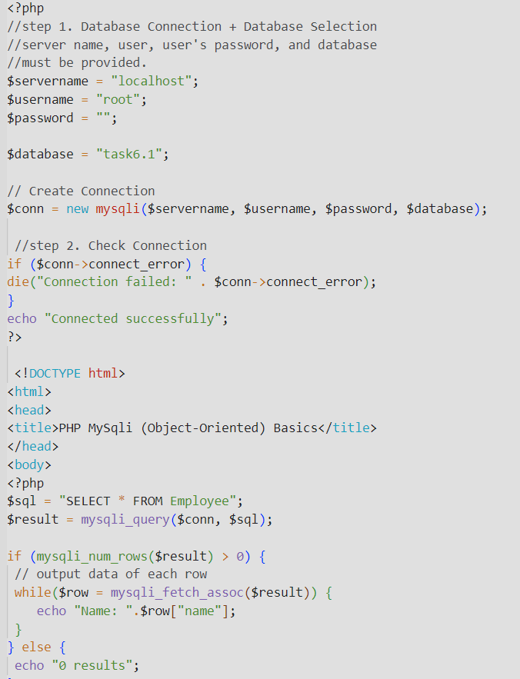

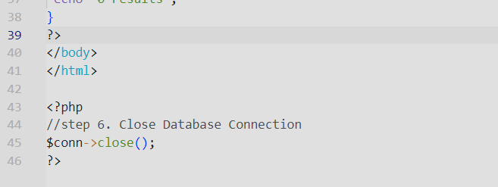

**OutPut:**

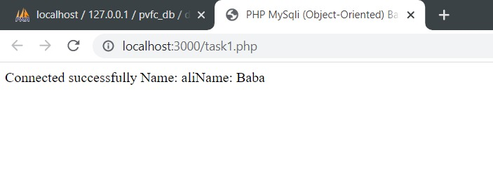

# **---------------------------Task 6.2---------------------------**

**Write PHP-MYSQLI Object-Oriented interface script that connects with one of the tables of your DBMS Lab Project (For instance, user table or accounts table or any of your choice). Perform the following:**

1. **Apply the insert command on the table. Take the data from user via HTML Form constructs.**
2. **Apply the update command on the table. Take the data from user via HTML Form constructs.**
3. **Apply the delete query on the table. Take the data from user via HTML Form constructs.**
4. **Apply the select query on the same table to retrieve data. Show the data in HTML Form Constructs.**

**Code:**

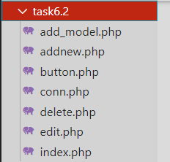

* **Add_Model.php**

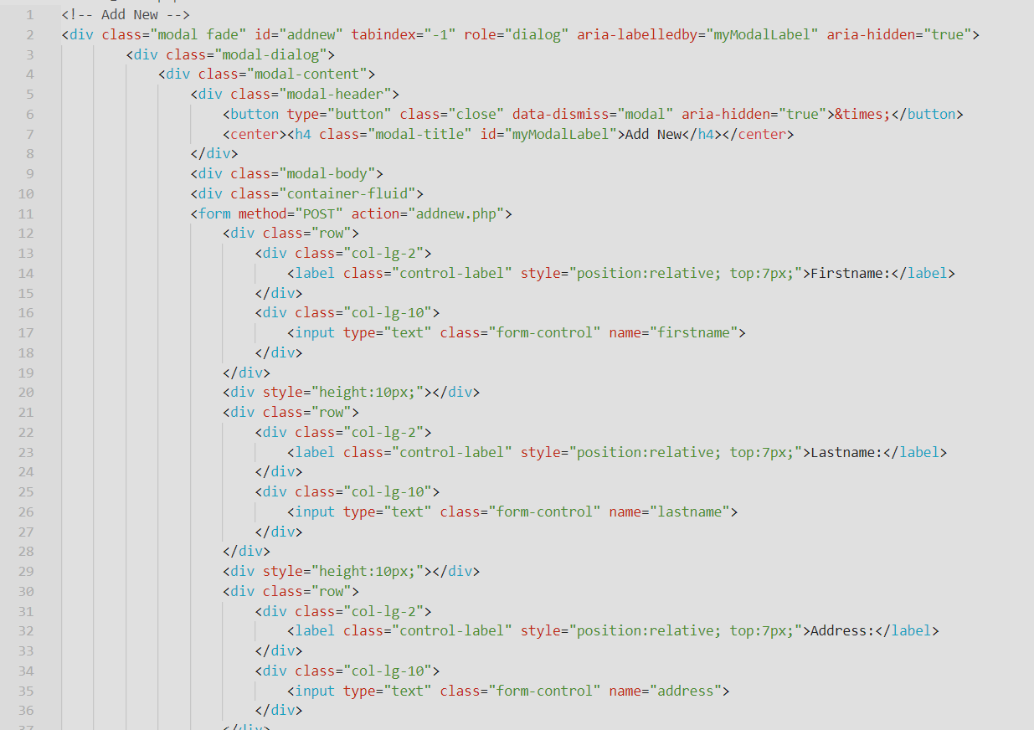

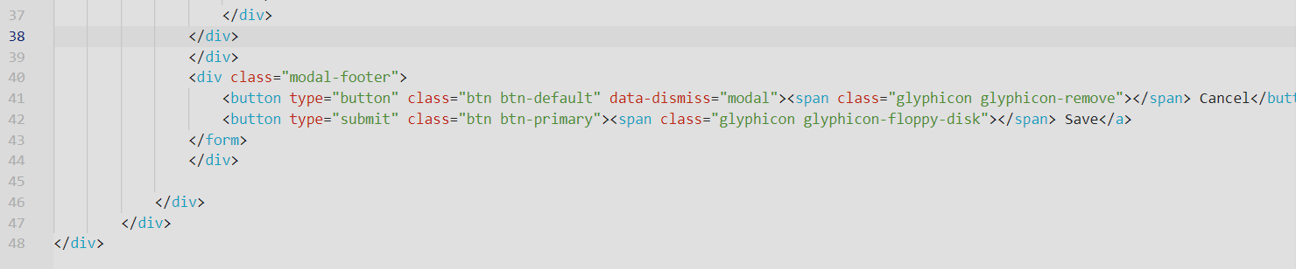

* **Addnew.php**

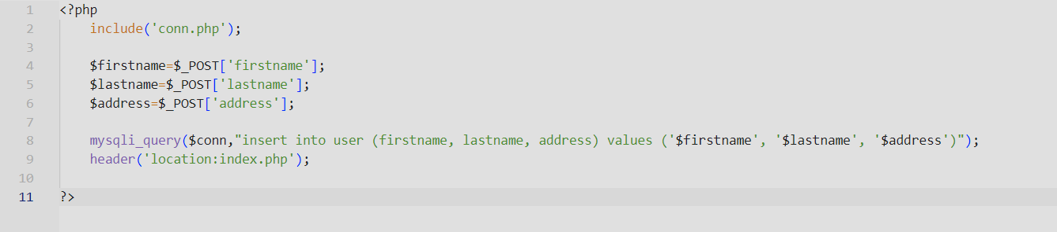

* **Button.php**

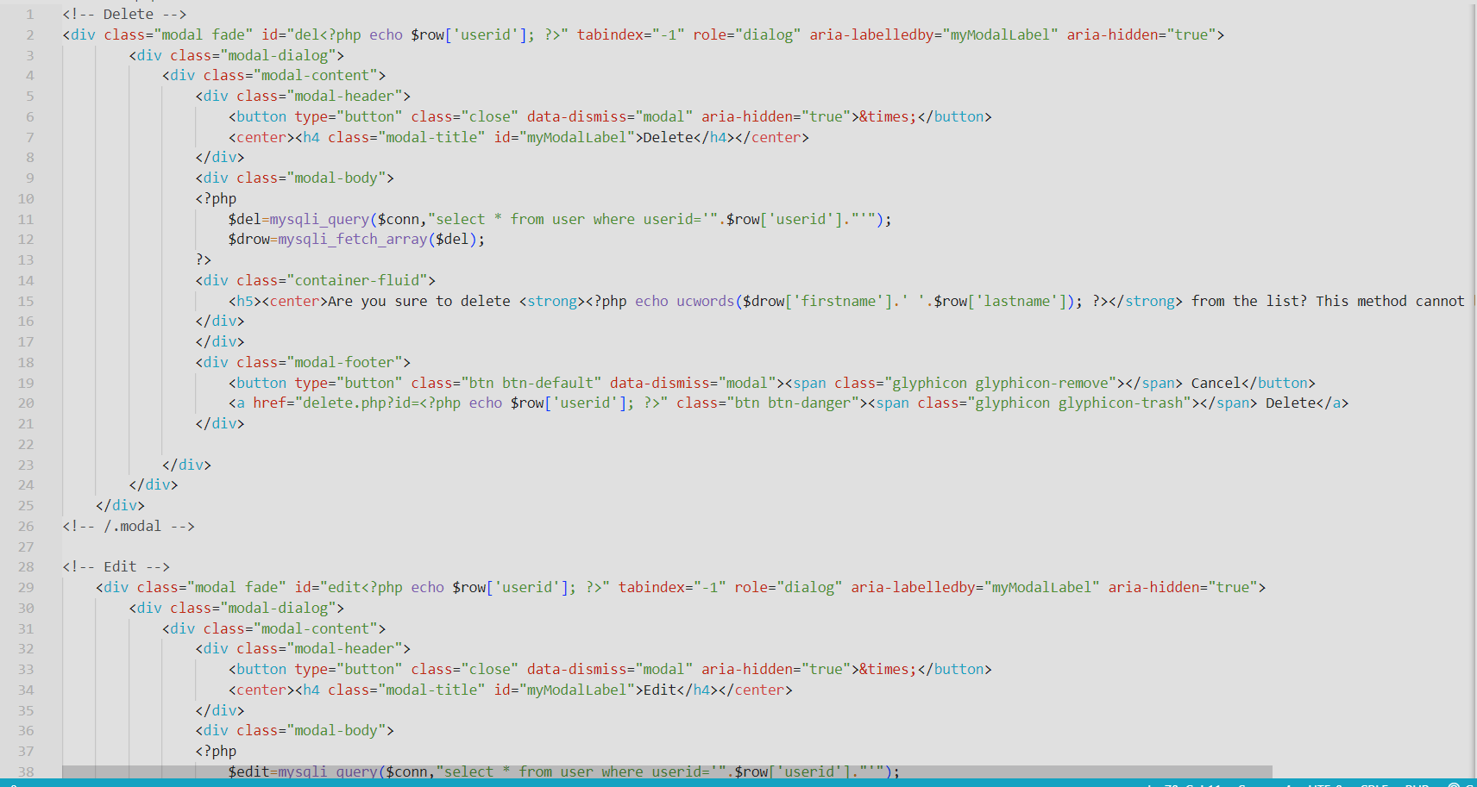

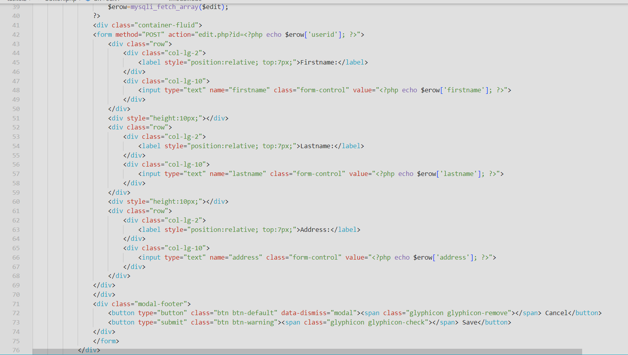

* **Conn.php**

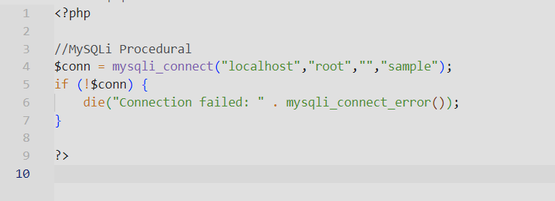

* **delete.php**

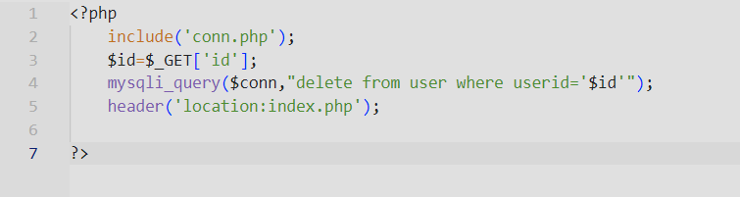

* **edit.php**

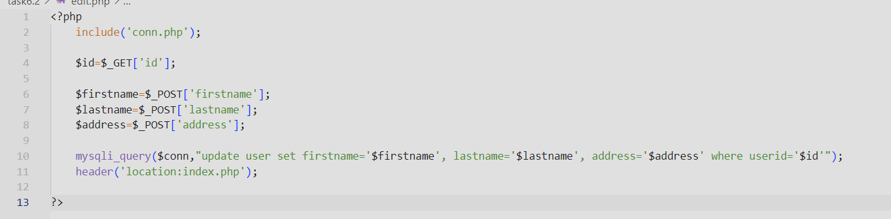

* **index.php**

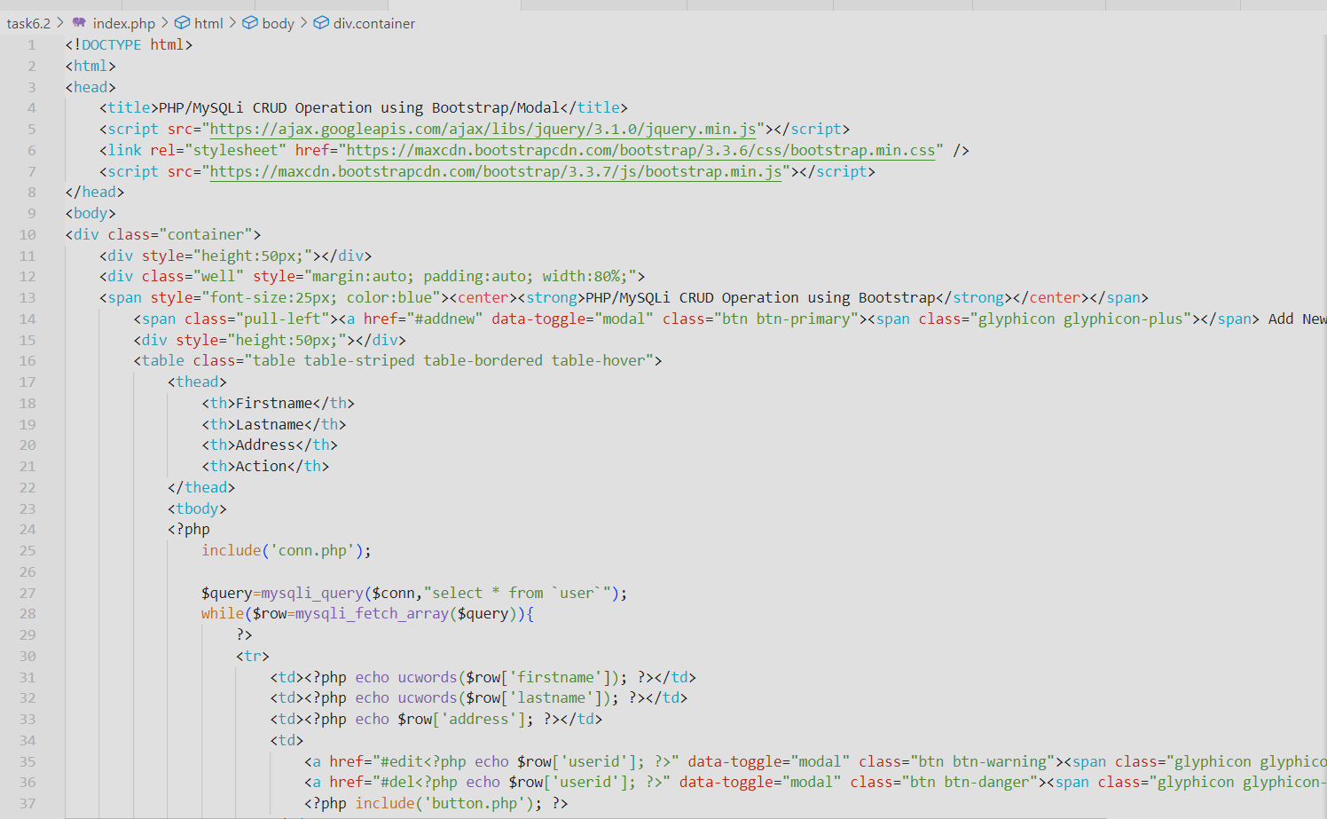

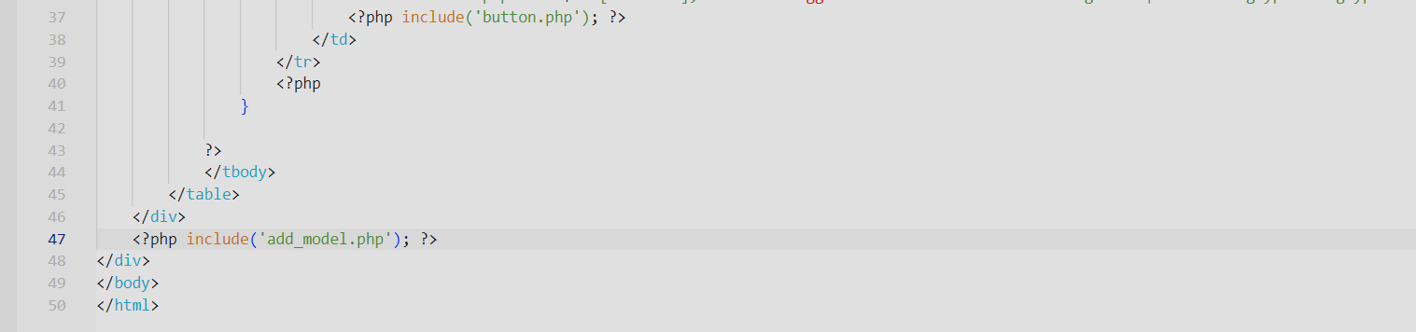

**Output:**

* **Add new**

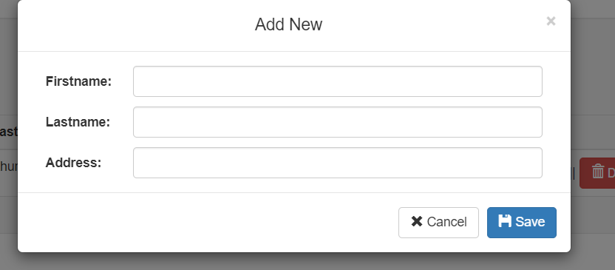

* **Edit:**

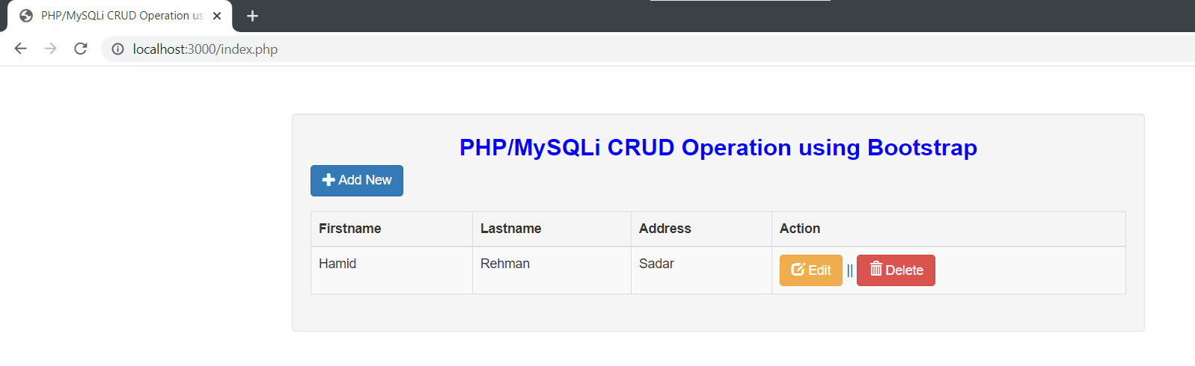

* **Stored Data in PhpMyadmin:**

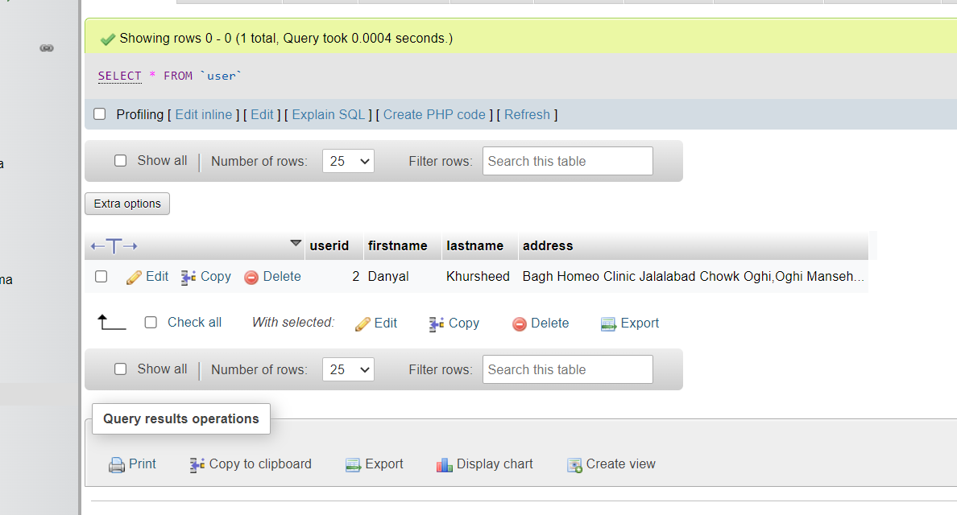

**---------------------------Task 6.3---------------------------**

**Perform Task 6.2 using PHP-PDO (PHP Data Objects) interface.**

**Code:**





**OutPut:**



# **---------------------------Task 6.2---------------------------**

**Write PHP-MYSQLI Object-Oriented interface script that connects with one of the tables of your DBMS Lab Project (For instance, user table or accounts table or any of your choice). Perform the following:**

1. **Apply the insert command on the table. Take the data from user via HTML Form constructs.**
2. **Apply the update command on the table. Take the data from user via HTML Form constructs.**
3. **Apply the delete query on the table. Take the data from user via HTML Form constructs.**
4. **Apply the select query on the same table to retrieve data. Show the data in HTML Form Constructs.**

**Code:**

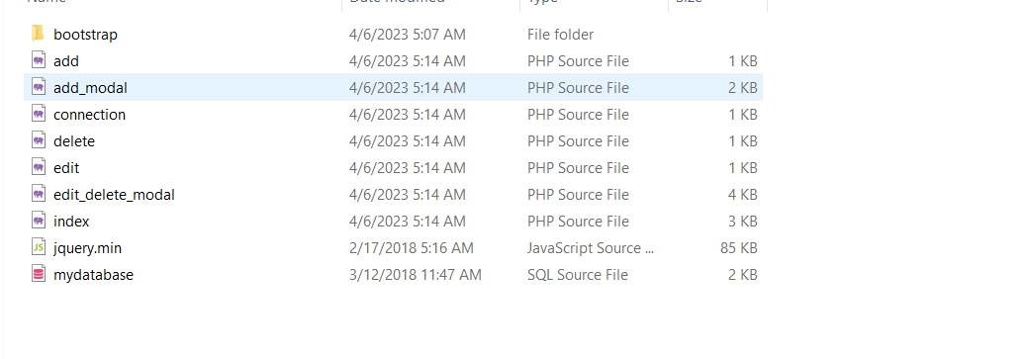

* **Add.php**

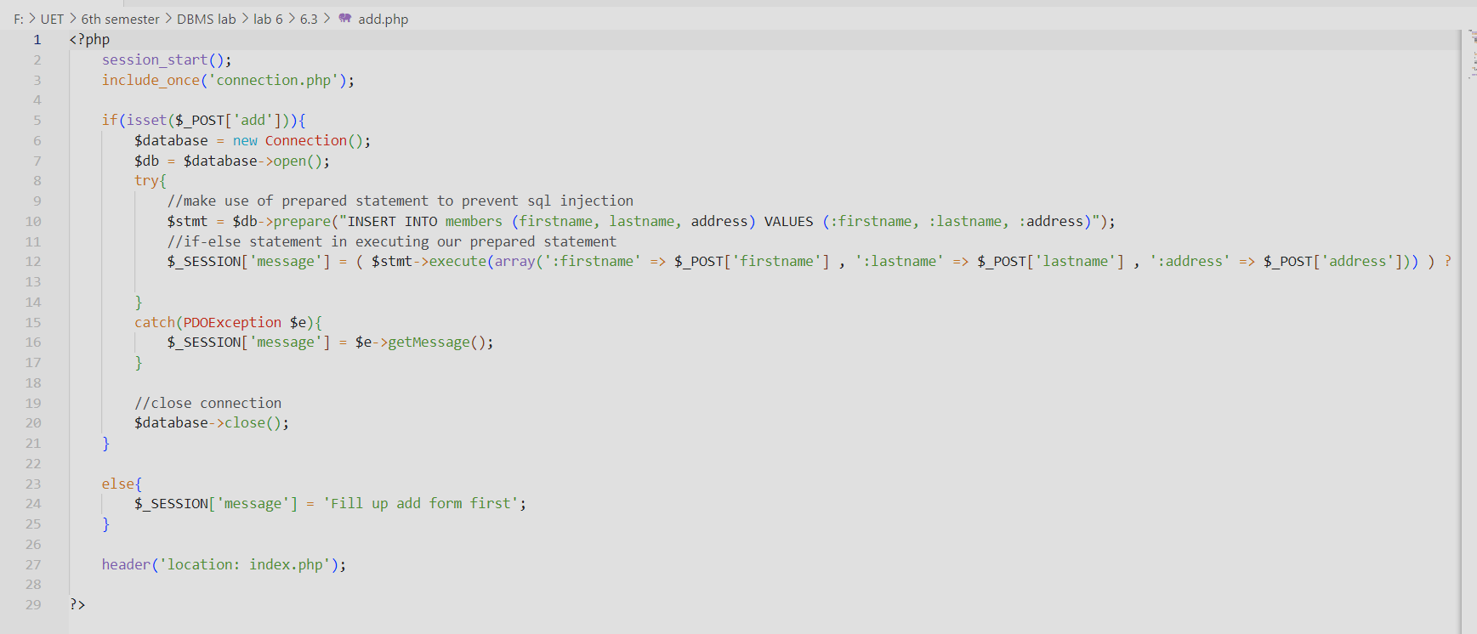

* **AddModal.php:**

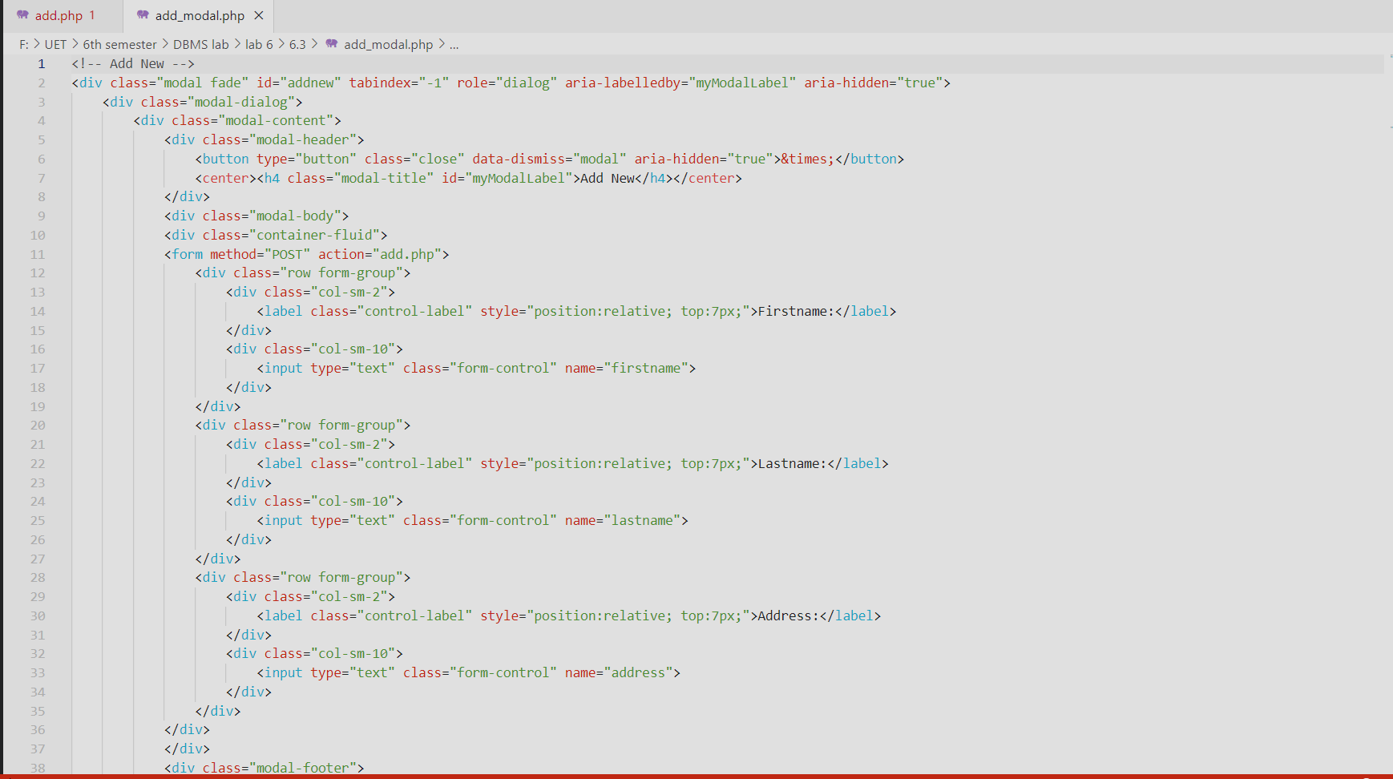

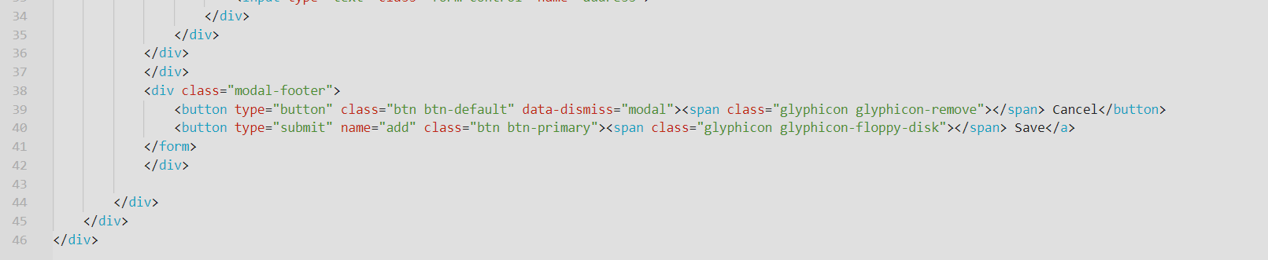

* **Conn.php**

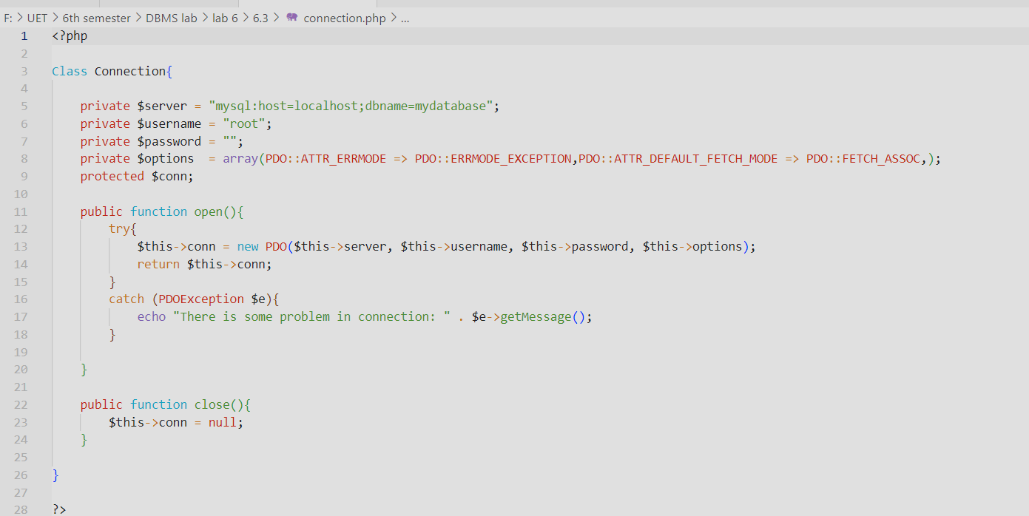

* **edit.php**

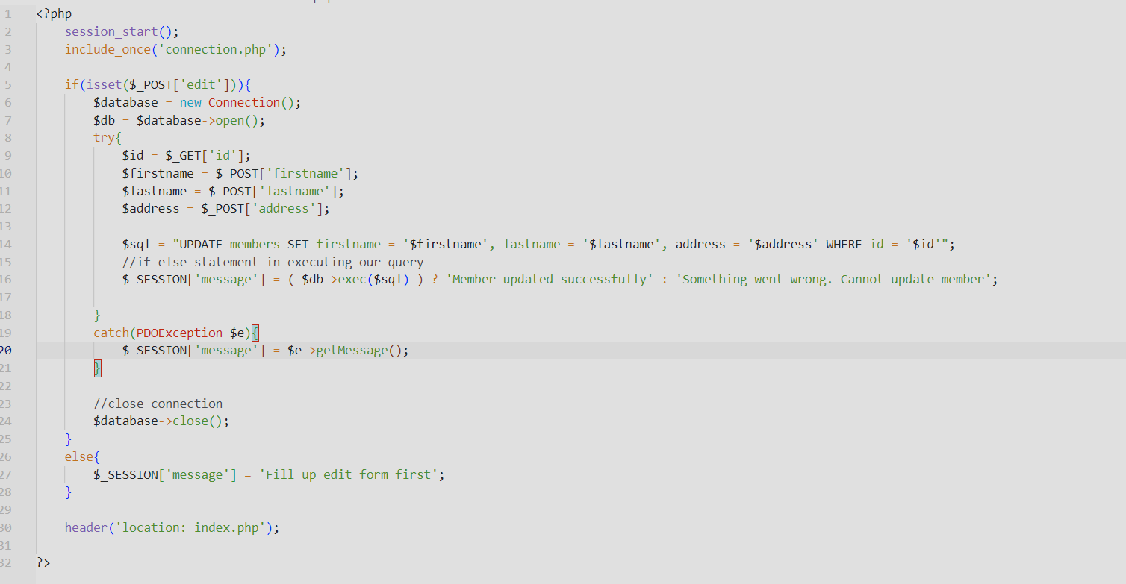

* **index.php**

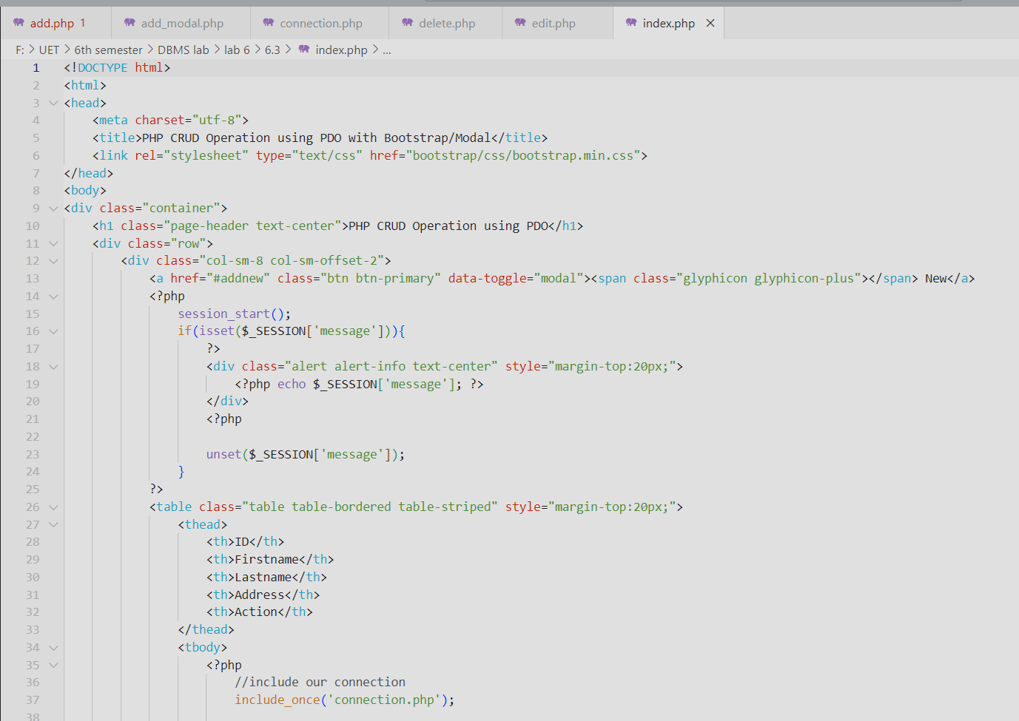

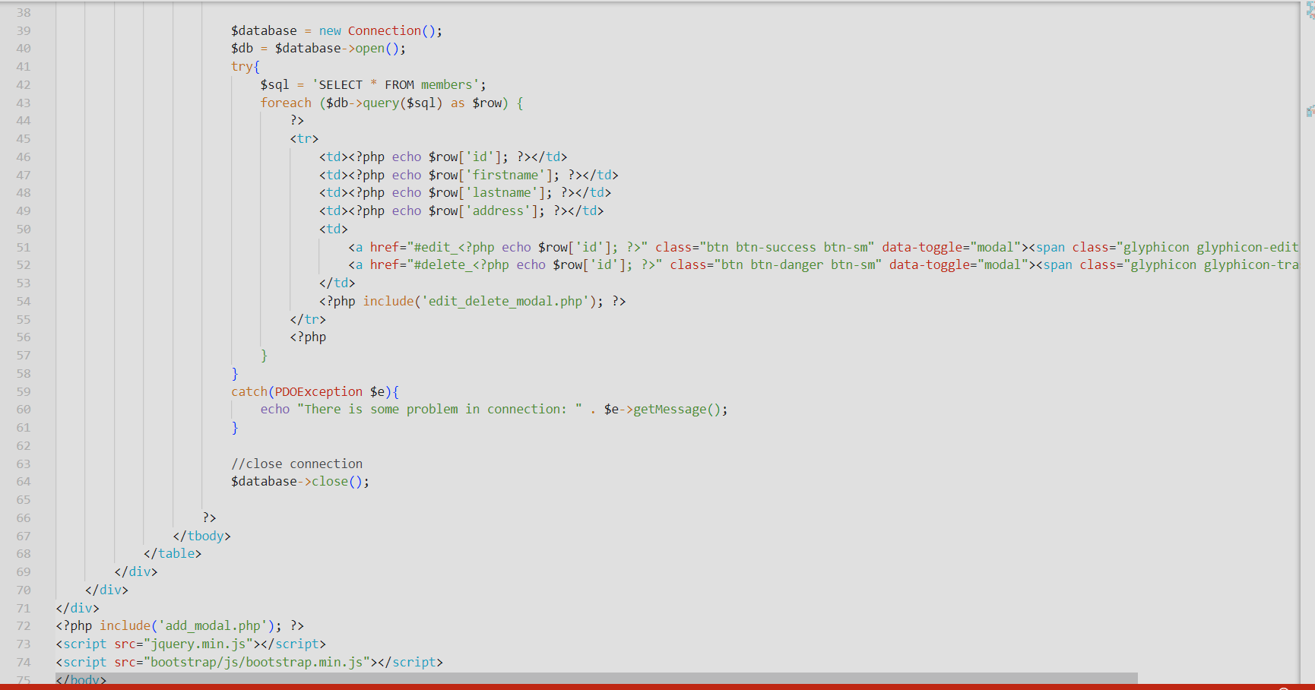

**Output:**

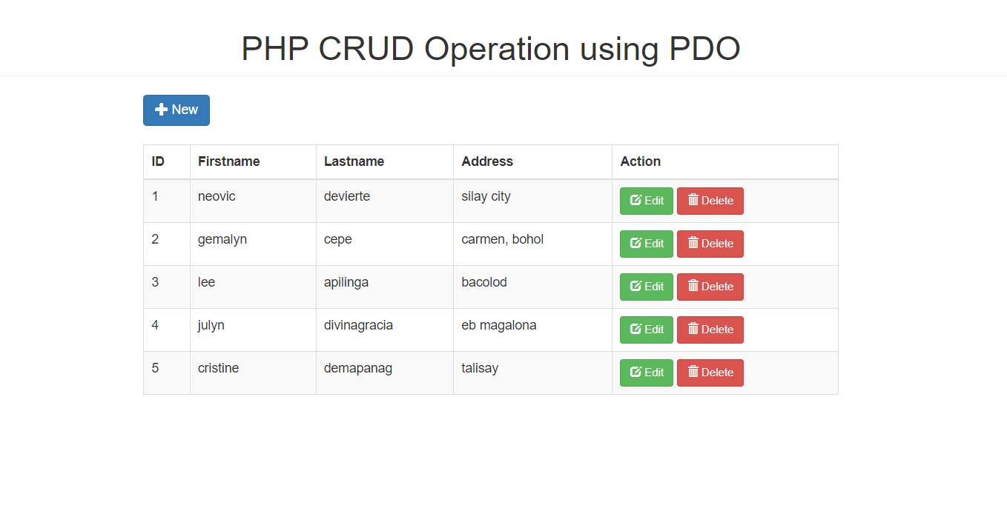

* **Add new**

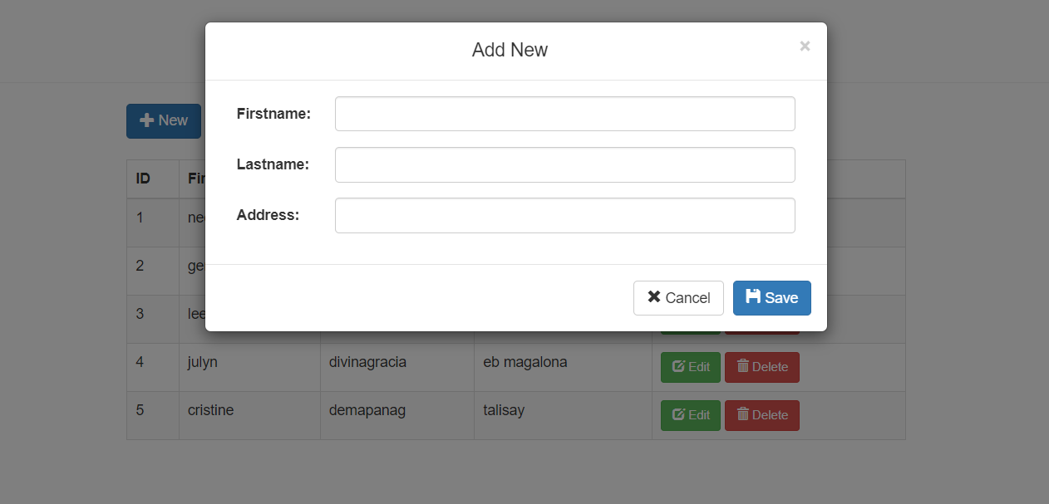

* **Edit:**

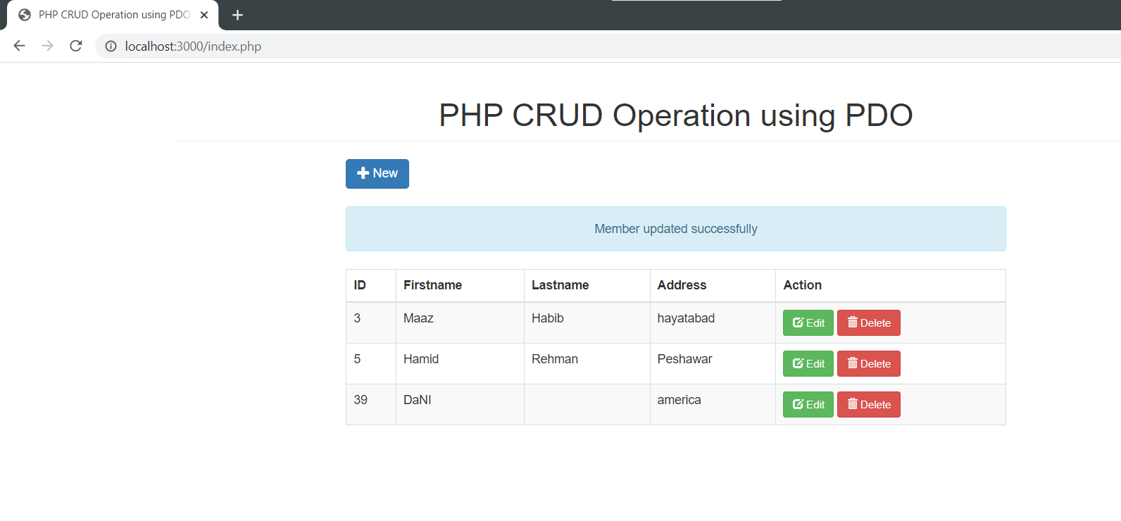

* **Stored Data in PhpMyadmin:**

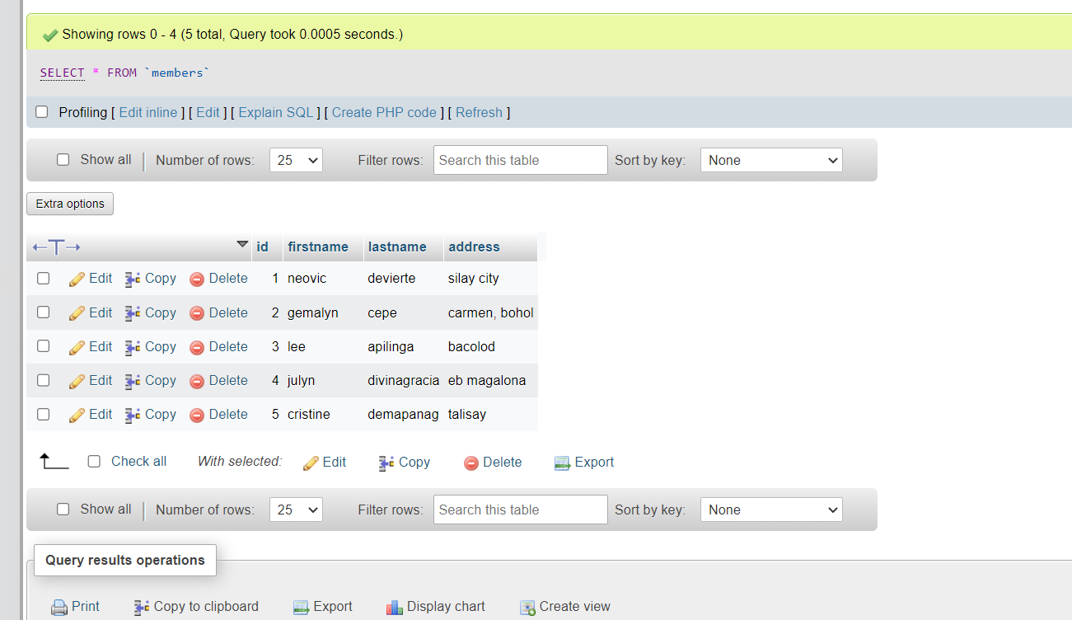

# ---------------------------Task 6.4---------------------------

Perform Task 6.2 using LARAVEL.

**Create.blade.php**

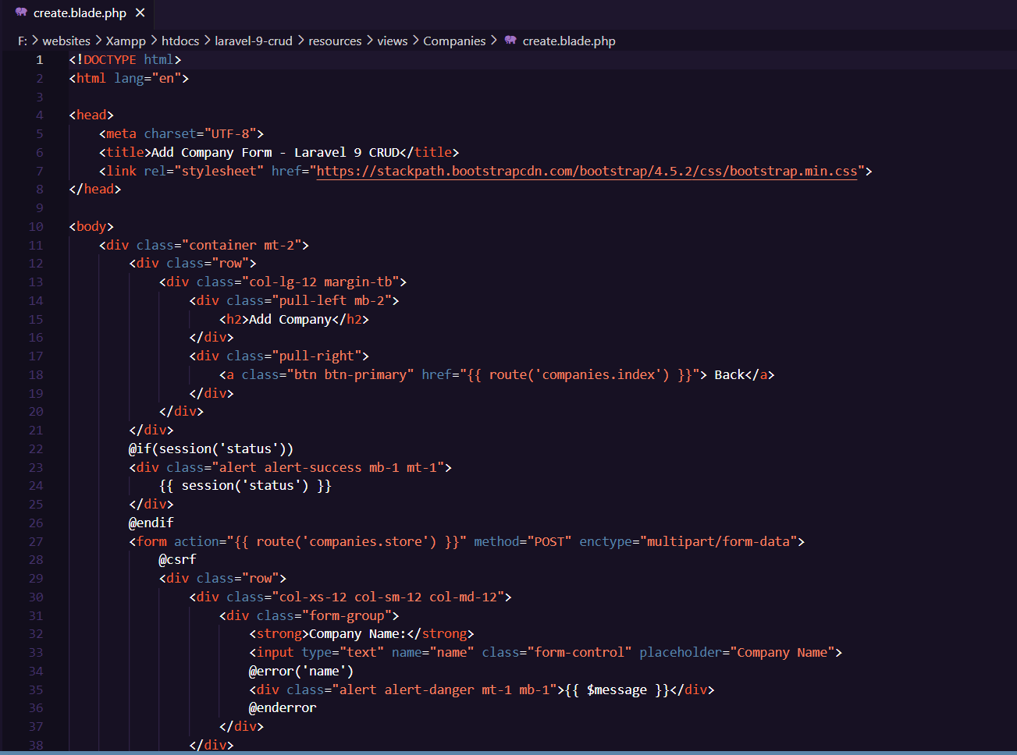

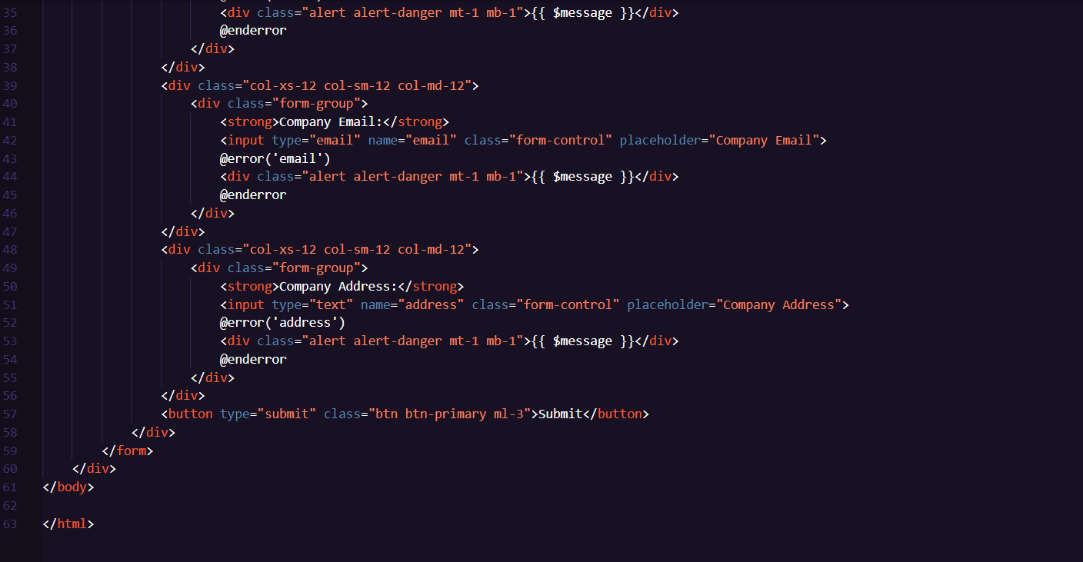

**Edit.blade.php:**

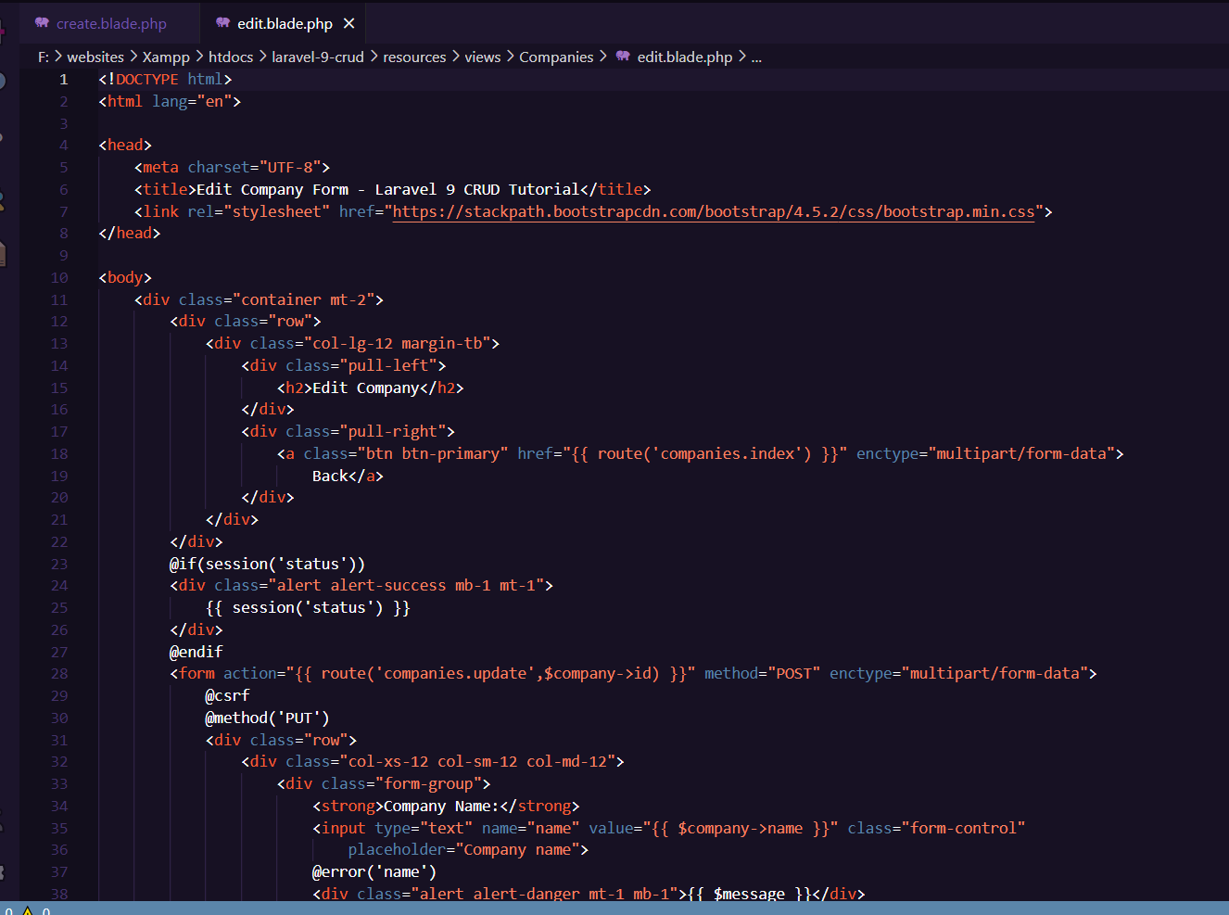

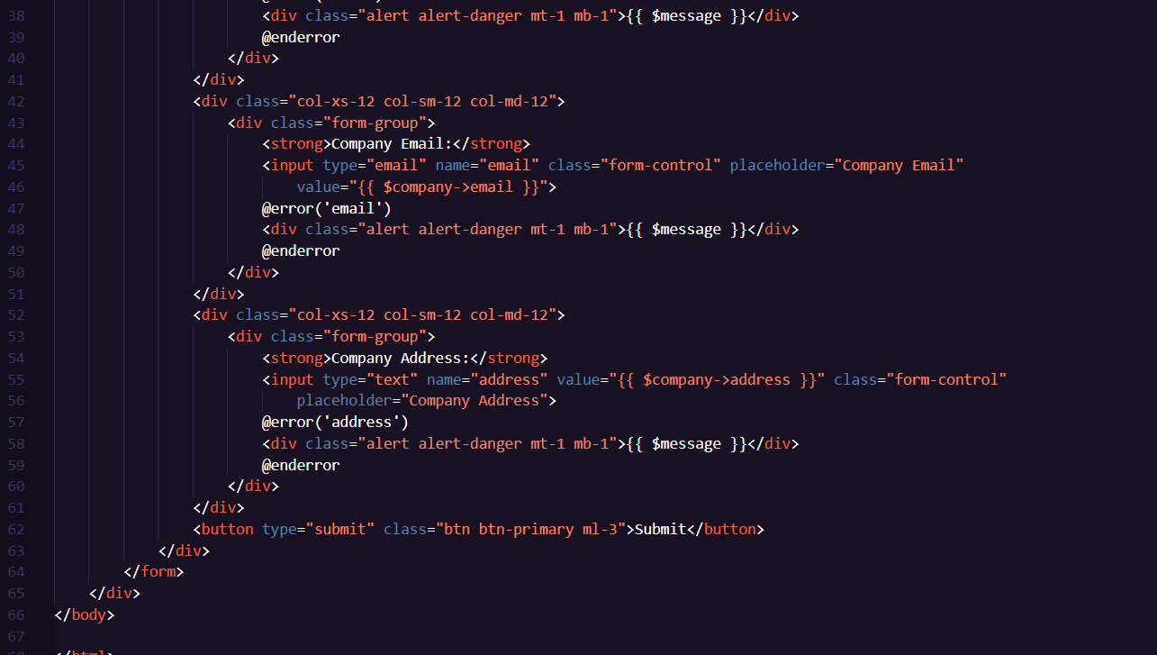

**Index:**

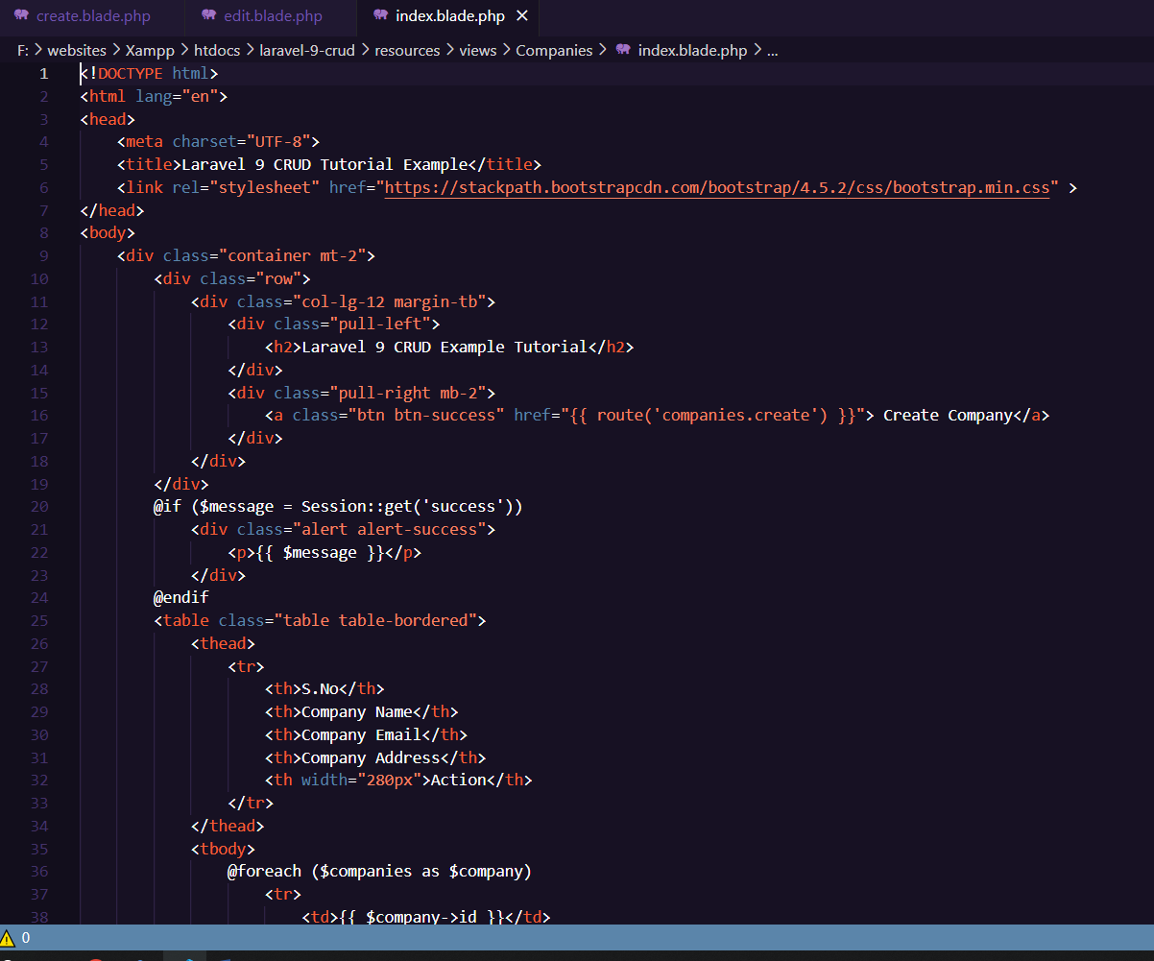

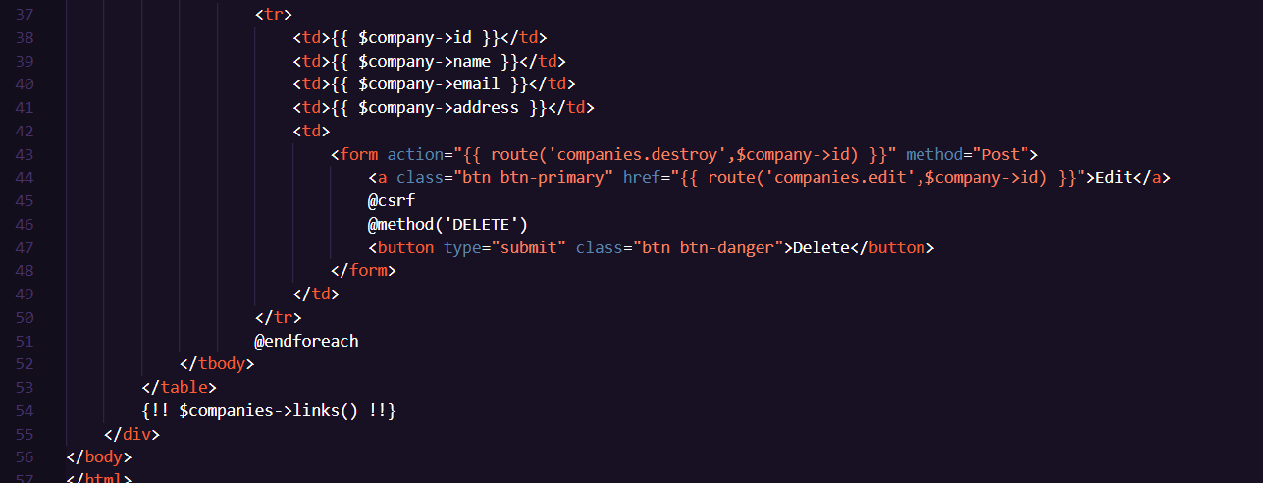

**OutPut:**

